**Parents as Teachers Newsletter**



**Parents as Teachers Partners with the St. Louis Diaper Bank**

The period supplies program works similarly to the diaper program by assisting individuals with access to period supplies thus ensuring students are not missing out on their education and ability to work simply because they have a period.

The Diaper Bank is able to provide families with diapers and period supplies via community donors.

Thanks to the generous donation of **The St. Louis Diaper Bank** the **Ferguson**-**Florissant Parents as Teachers** program is able to provide families with needed diapers and period supplies. Parent Educators deliver diapers and period supplies to parents once a month during the completion a home visit.

**Need Diapers or Period Supplies? Contact your parent educator.**

**The St. Louis Area Diaper Bank** provides families in need with free diapers and influences a range of positive outcomes for families, such as positive changes in parental mood; improved child health and happiness; and increased opportunities for childcare, work stability, and school attendance

As of 2022, 1 in 3 families were unable to provide an adequate supply of diapers for their children in the United States. It costs around $120 to up to $200 a month to diaper a child for a year - depending on brands, access to affordable sources, diaper size, and individual child needs. This is nearly 10% of a minimum wage worker's take-home pay.

In addition to diapers, the **St. Louis Area Diaper Bank** is able to provide period supplies.  It costs $478 each year to purchase period supplies for one woman or girl.

In 2022, 1 in 5 low-income women in St. Louis were unable to afford period supplies at least once during the year. 1 in 5 girls have missed school due to a lack of period supplies. A 2021 study by Kotex nationally found that period poverty has increased in the United States since the pandemic and it is disproportionally affecting women of color.

C



Keeping infants and toddlers clean, dry and healthy is key to building a solid foundation for all children.



**Be On the Look Out**

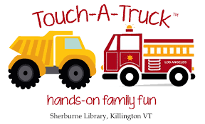

**Upcoming Parents as Teachers Group Connections**

**January 18** **Books and Cooks**

Wednesday 5:30 – 6:30 pm Virtual

Parents and children will have fun cooking together and reading cooking stories

**February 27**  **Safe, Sleep, Breastfeeding and CPR**

Monday 5:30 – 6:30 pm Location TBA

**February** **Life-size** **Candyland Game**

Come and make your way to the Candy Castle in a.  Fun for the whole family!

Location, date and time TBA

**April 24** **Dad, The Science Guy**

Monday Dad and child will enjoy participating in three science experiments

6:30 -7:30 Walnut Grove Elementary School ***Registration is required***

**April**  **Celebrate Spring at Little Creek**

Join us for fun in nature! There will be lots of activities, including a book walk, outdoor play space, feeding animals & more!

Little Creek Nature Area. Date and time TBA

**May** **Touch a Truck**

Children will enjoy getting an up-close, hands on view of various kinds of trucks.

Location, date and time TBA

**May**  **Messy fun!**

Children will enjoy have a variety of sensory stimulating activities, including painting, bubbles and more!

Location, date and time TBA

**June**  **Kindergarten Readiness**

Discussion on school readiness, routines and play games to strengthens social and academic skills. Location, date and time TBA

**Parents as Teachers** is in the process of emailing a program survey to families. We want to know how you feel about the services you receive, as well as, suggestions for improvement. If you do not receive a program survey in your email inbox by the end of December please ask you parent educator to provide the survey to you.



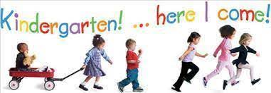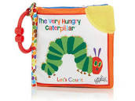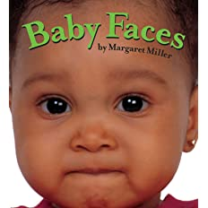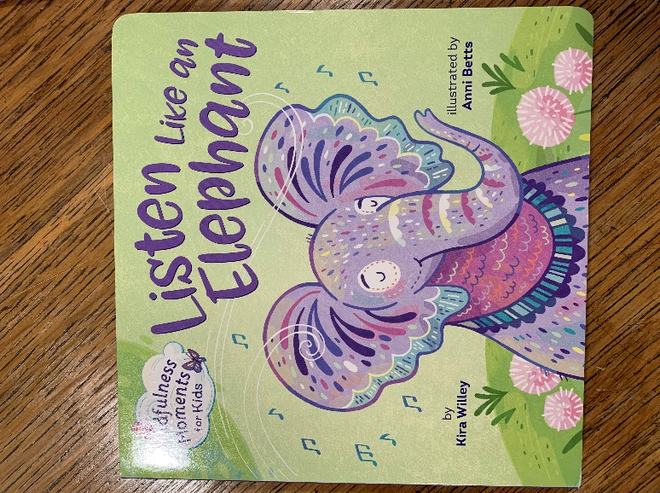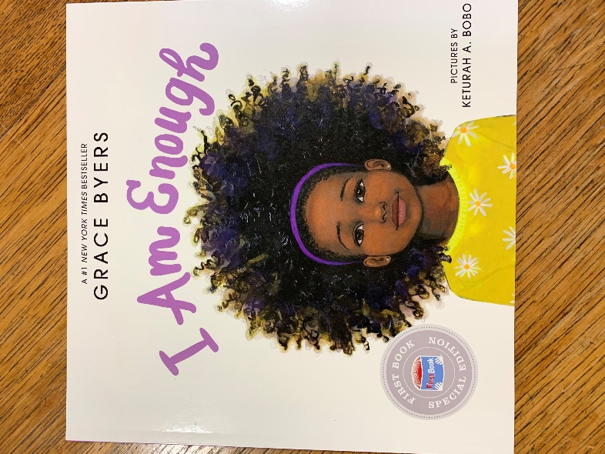

Enrollment for the 22/23 school year has ended.

Please check the website in January for 23/24 enrollment updates.

Attention all incoming Kindergarten students!

Kindergarten Enrollment for the 23/24 school year will take place in March.

Continue to check our website, [fergflor.org](http://fergflor.org/) – Programs, for details.

**Unique Preschool Opportunity for 3s and 4s for the 23/24 School Year**

**Preschool at Little Creek** is a unique program providing an outdoor learning experience for children one or two days each week.  Transportation is not included and is provided by the parent.  The routine and schedule at Little Creek is consistent with daily class routines and schedules.  Children engage in outside centers and exploration, small and large group activities, music and movement, story time and snack.  In addition, children will go on explorations and daily hikes while at Little Creek.  Children enrolling in the Little Creek Program at Parker Road also receive home visits by your child's teacher as a part of our Parents as Teachers Program.

3 year olds: Tuesday morning at Parker Road, Thursday morning at Little Creek (weather permitting)

4 year olds: Monday morning at Parker Road, Wed/Fri at Little Creek (weather permitting)

For information contact [kstealey@fergflor.org](mailto:Fkstealey@fergflor.org)

**Babies Enjoy Many Types of Books**

Babies love to look at other babies! This book shows close ups of diverse babies faces catching some of the classic expressions.

Board Books

Soft Cloth Books

Touch and Feel Books

Plastic Books

Soft Picture Blocks

**Books for Baby**

**Books for Toddlers and Preschoolers**

The message throughout this book is one of **self-worth and embracing differences**. Byers emphasizes that regardless of one's looks, abilities, or beliefs, every child is unique, able, and worthy of respect. Her message encourages children to recognize diversity and show respect and kindness to others.

[Listen like an Elephant is the third in the series of Mindfulness Moments board books, written by Kira Willey. When reading this book kids learn to slow down, listen to the world around them, and focus their minds--no matter how messy life becomes.](https://www.audible.com/pd/Mindfulness-Moments-for-Kids-Listen-Like-an-Elephant-Audiobook/059334118X)

**Choosing Age Appropriate Toys to Enhance Your Child’s Development**

Your toddler begins to play with toys differently than he/she did as a baby. As a baby he explored by using his senses. As a toddler your child uses toys to practice new skills: building, creating, problem solving and using objects to represent real world objects.

**Toys for Toddlers**

Board books, pop-up books,

Stacking toys

Shape sorter

Large-piece puzzles

Matching and sorting games

Trains, cars, trucks

Push toys

Peg boards

Finger paint, play dough, crayons, and markers

Play versions of real objects

Riding toys, doll strollers, wagons, rocking horses

Large balls

Alphabet blocks

Magnetic letters

Colored objects

Plain and colored paper

Play is learning! Choosing appropriate toys is important. Every time you play with your child you are strengthening your child’s brain connections necessary for developmental growth. When choosing toys keep in mind your child’s temperament, age, and cognitive development.

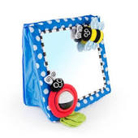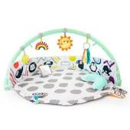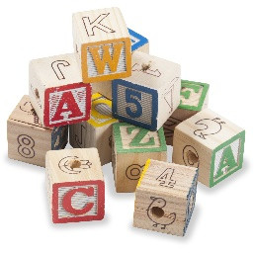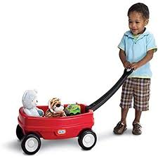

Before purchasing toys ask yourself:

Is this toy age appropriate for my child?

What skills will my child learn from this toy?

Will my child like this toy?

Do we have room for the toy in our house?

Is this a quality, durable and safe toy?

**Toys for Babies**

Activity mats

Mirrors

Stuffed toys

Soft dolls

Soft blocks

Blocks that make noise when banged together

Nesting cups

Stacking rings

Push and pull toys

Shape-sorters

Bubbles

Low climbing structures

Containers with objects to fill and dump

Safe household items like measuring cups and unbreakable bowls

Bath toys –floating toys, plastic books, cups







Kids and Car Safety has important safety information and resources on their website.

They offer A Child Proof Your Ride safety checklist, a before locking your vehicle checklist, information on children left in a vehicle alone state and federal laws and much more.



The website provides information on how to obtain a [**resqme emergency tool**](https://www.kidsandcars.org/product/resqme-emergency-tool/). Resqume tool is a window breaker and seat belt cutter, emergency tool that hooks right on your keychain. This tool is essential for saving you child’s and your life if caught in an emergency situation as fire in the vehicle or a vehicle being submerged in a body of water.

[www.KidsandCarSafety.Org/Childpoofyour](http://www.KidsandCarSafety.Org/Childpoofyour)

Childproofing your home is second nature. Parents cover electric outlets, shorten shade cords, lock up medication and other poison hazards, utilize door locks etc. to keep their child (ren) safe in their home.

Have you ever thought the hazards that exist around vehicles? The Kids and Car Safety Organization has. Their mission is to eliminate vehicle-related risks to children and pets.

The organizations focus is on everyday events referred to as “nontraffic incidents” which includes being run over in parking lots or driveways, hot car deaths, carbon monoxide poisoning, car theft with children/animals inside, falls, knocking cars into gear, drowning from not being able to exit a submerged vehicle, underage drivers, power window strangulation, trunk entrapment, etc.

**Child Proof Your Ride**

# 

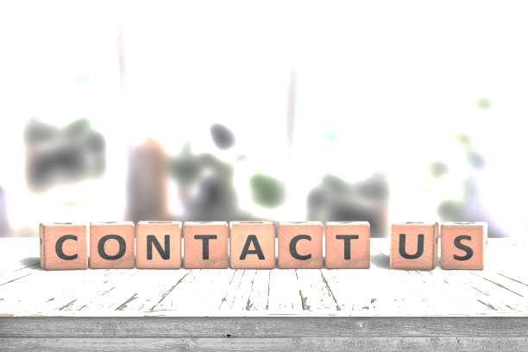

**Follow us on Social Media!**

Shantana Herd-Luckett, **Director of Early Education**; 314-8242017,sluckett@fergflor.org

**Parents as Teachers** – Debra Smith McCutchen, Coordinator; 314-824-2076, [dmccutchen@fergflor.org](mailto:dmccutchen@fergflor.org)

Cynthia Wise, **Early Childhood Special Education** Assistant Director; 314-824-2072,

[cwise@fergflor.org](mailto:cwise@fergflor.org)

Kathy McGee, **Head Start**, Supervisor; 314-687-1972, [kmcgee@fergflor.org](mailto:kmcgee@fergflor.org)